**Alumni Network: An Academic Portal using Machine Learning**

**Table of Contents**

ABSTRACT 2

1. INTRODUCTION 3

1.1 Motivation 3

1.2 Problem Statement 3

1.3 Objective of the project 4

1.4 Scope of the project 4

1.5 Project Introduction 4

2. LITERATURE REVIEW 6

2.1. Alumni Engagement Platforms 6

2.2. Chatbots and Machine Learning in Educational Systems 6

2.3. Role of LSTM Networks in Natural Language Processing 7

2.4. Security and Data Management in Alumni Networks 7

2.5. Personalization and Automation in User Engagement 7

3. SYSTEM ANALYSIS 8

3.1 Existing System 8

3.2 Disadvantages of existing systems 8

3.3 Proposed System 8

3.4. Advantages of Proposed System 9

3.5 Project flow 9

4. METHODOLOGY 10

4.1 Backend Development 10

5. REQUIREMENT ANALYSIS 14

5.1 Function and non-functional requirements 14

5.2 Hardware Requirements 15

5.3 Software Requirements 16

6. SYSTEM DESIGN 16

6.1 UML diagrams 16

6.1.1 USE CASE DIAGRAM 17

6.1.2 CLASS DIAGRAM 18

6.1.2 SEQUENCE DIAGRAM 19

6.1.4 COLLABORATION DIAGRAM: 20

6.1.5 DEPLOYMENT DIAGRAM 21

6.1.6 ACTIVITY DIAGRAM: 22

6.1.7 COMPONENT DIAGRAM: 23

6.2 ER DIAGRAM: 24

6.3 Data Flow diagrams 25

7. IMPLEMENTATION AND RESULTS 27

7.1 Modules 28

CONCLUSION 29

FUTURE ENHANCEMENT 31

REFERENCES 32

**ABSTRACT**

The Alumni Network: An Academic Portal using Machine Learning is an innovative web platform designed to enhance engagement between alumni and their academic institution. The system enables alumni to register, interact with fellow alumni, participate in academy events, and stay updated with academy news. Administrators can manage alumni data, approve registration and event requests, and update academy content, such as events, news, and galleries. The platform also integrates an advanced chatbot powered by Long Short-Term Memory (LSTM) networks to efficiently handle user inquiries. This portal serves multiple user roles: Admin, Alumni, and Guests. Alumni can register, chat with others via the chatbox, and book events, while prospective users can explore the gallery, news, and interact with the chatbot for information about the academy. Admins handle backend processes, such as managing alumni registrations and event requests. The system’s user-friendly design, coupled with automated features like the chatbot and email notification system, creates an efficient and streamlined experience for both administrators and alumni. Additionally, the system ensures security through robust authentication and validation mechanisms, safeguarding user data and interactions. This project provides a seamless digital platform for strengthening alumni relationships, enhancing event management, and fostering ongoing engagement between alumni and their alma mater.

**Keywords**: Alumni Network, Admin, User, Chabot, Chat box, Academy.

1. **INTRODUCTION**
   1. **Motivation**

The motivation behind this project stems from the need to strengthen the relationship between academic institutions and their alumni, fostering long-term engagement and networking. Alumni represent a vital resource for institutions, contributing to their reputation, mentorship, and potential funding. However, many institutions lack an efficient and user-friendly system for alumni to stay connected, access important updates, and engage in meaningful ways. By leveraging machine learning, particularly an LSTM-based chatbot, this project aims to create a platform that not only simplifies alumni interactions but also automates administrative tasks, ensuring a seamless experience for both alumni and administrators.

**1.2 Problem Statement**

Educational institutions often struggle to maintain ongoing engagement with their alumni and effectively manage alumni data, event participation, and communication. Existing platforms lack streamlined tools for alumni networking and interaction, administrative oversight, and automated assistance. This project aims to address these challenges by developing a centralized Alumni Network Portal using Machine Learning, incorporating advanced chatbot features to facilitate alumni communication, event management, and overall engagement, while ensuring secure data handling and user authentication.

## **Objective of the project**

The objective of this project is to create a seamless, secure platform for alumni to engage, administrators to manage data, and users to explore academy content, enhanced by an LSTM-based Chabot.

* 1. **Scope of the project**

The scope of this project includes the development of a comprehensive web platform that facilitates interaction between alumni and their alma mater. Key features include alumni registration, event participation, networking through a chat system, and access to academy updates like news and gallery content. The system provides a secure admin panel for managing alumni data, event requests, and academy content. Additionally, a machine learning-powered LSTM chatbot will handle user inquiries. Future enhancements could include personalized event recommendations, advanced analytics for alumni engagement, and the integration of mobile-friendly interfaces for better accessibility.

**1.5 Project Introduction**

Alumni Network: An Academic Portal using Machine Learning is an innovative web platform designed to strengthen the relationship between academic institutions and their alumni by facilitating communication, event management, and continuous engagement. The platform serves three primary user roles: Admin, Alumni, and Guests, with each role having specific features aimed at enhancing interaction and streamlining administrative tasks.

The platform's core functionality revolves around alumni registration, event participation, and networking. Alumni can register and log in after admin approval, connect with other alumni through a secure one-on-one chatbox, and stay updated on academy events and news. The system allows alumni to book event slots, participate in discussions, and access information about their alma mater. The platform also allows prospective users (Guests) to explore gallery images, view academy news, and interact with an LSTM-based chatbot for general inquiries such as fee structures, course details, and more.

For the administrators, the platform simplifies the management of alumni registrations, event bookings, and academy content like news and gallery updates. Admins have the ability to approve or reject registration and event requests, ensuring secure and validated access. The system also automates notifications, sending emails to alumni regarding the status of their requests.

The machine learning component of this platform is embodied in the LSTM (Long Short-Term Memory)-based chatbot. This advanced chatbot provides automated user assistance, handling common inquiries and offering quick responses regarding academy details. The chatbot is available to both registered and non-registered users, making it a key feature for fostering user engagement and streamlining information dissemination.

The Alumni Network portal's user-friendly design, integrated chatbot, and email notification system provide an efficient, secure, and streamlined experience. By centralizing alumni engagement and leveraging machine learning, the platform aims to foster long-term relationships between alumni and their alma mater. Additionally, it opens up future opportunities for personalized event recommendations, advanced analytics on alumni engagement, and mobile-friendly access for a wider reach, ensuring the institution remains connected with its global alumni base.

# **2. LITERATURE REVIEW**

**2.1. Alumni Engagement Platforms**

The concept of alumni engagement platforms has evolved significantly over the years. Traditionally, alumni networks were maintained through manual processes, emails, and social media platforms. However, modern technological advancements have shifted these engagements to dedicated web-based platforms. Studies by Briones et al. (2011) have emphasized that alumni relations benefit from centralized platforms that streamline communication, event management, and news updates. However, these systems often lacked machine learning components to automate and personalize interactions, which highlights the need for enhanced platforms incorporating AI-driven tools like chatbots and recommendation systems.

**2.2. Chatbots and Machine Learning in Educational Systems**

The introduction of chatbots in educational systems has demonstrated significant potential in automating interactions and improving user experience. Research by Pérez-Marín et al. (2020) demonstrated how educational institutions can deploy AI-driven chatbots to manage frequent queries, handle student or alumni requests, and provide automated assistance. The integration of machine learning, particularly using models like Long Short-Term Memory (LSTM) networks, allows chatbots to offer more accurate and context-aware responses. Multiple studies, including one by Hussain et al. (2019), have shown that chatbots improve user satisfaction and engagement by offering instant query resolutions and automating routine administrative tasks.

**2.3. Role of LSTM Networks in Natural Language Processing**

Long Short-Term Memory (LSTM) networks are widely used for various natural language processing (NLP) tasks such as text classification, language translation, and chatbot development. In the context of alumni engagement systems, LSTMs have been employed to enhance chatbot functionalities. A study by Hochreiter and Schmidhuber (1997), who initially developed LSTM, shows that LSTM's ability to learn long-term dependencies in sequential data makes it ideal for tasks involving conversations or dialogue systems. Research by Sutskever et al. (2014) demonstrated that LSTMs outperform traditional models in sequence prediction tasks, further validating their effectiveness in chatbot applications for handling complex queries in real-time.

**2.4. Security and Data Management in Alumni Networks**

Security is a critical aspect of alumni networks, especially when managing sensitive user data such as personal details, event participation, and communication logs. Research by Anderson et al. (2016) highlighted the vulnerabilities in alumni engagement platforms, focusing on issues such as data breaches and identity theft. Solutions proposed in various studies emphasize the use of encryption, robust authentication mechanisms, and regular security audits to safeguard data. The development of machine learning models that can detect anomalies or potential security threats in real-time has also been explored by researchers like Shafiq et al. (2019), contributing to the security enhancements in such platforms.

**2.5. Personalization and Automation in User Engagement**

Modern alumni networks focus heavily on personalizing user experiences to increase engagement. Personalization techniques, powered by machine learning algorithms, have shown great promise in delivering tailored content, event recommendations, and relevant notifications. Research by Smith et al. (2018) explored how personalization significantly boosts user interaction and participation in alumni networks. Additionally, automation through email notifications, event reminders, and chatbot responses streamlines administrative tasks. Studies have shown that machine learning, particularly recommendation systems, improves alumni participation by suggesting relevant events and networking opportunities based on user behavior and history.

This literature survey demonstrates that integrating machine learning, particularly chatbots and LSTM models, into alumni networks enhances engagement, streamlines communication, and improves administrative processes while maintaining a secure and personalized user experience.

# **3. SYSTEM ANALYSIS**

## **3.1 Existing System**

In many educational institutions, alumni engagement and management are often handled through basic websites, social media groups, or manual processes such as email communications and event coordination. These systems typically lack integration, automation, and a dedicated platform for seamless alumni interaction.

## **Disadvantages of existing systems**

* Manual Processes: Alumni data management, event booking, and communication often rely on manual effort, leading to delays and errors.
* Lack of Engagement: Alumni interaction is limited to social media or isolated channels, which do not foster continuous engagement with the institution.
* No Centralized Platform: Information about alumni, events, and academy news is scattered, making it hard to access relevant updates efficiently.
* Poor Data Management: The absence of a proper system for alumni data management results in unstructured or outdated databases.

## **3.3 Proposed System**

The proposed system, Alumni Network: An Academic Portal using Machine Learning, is a dedicated web platform that centralizes alumni registration, event management, and communication. The platform features an LSTM-based chatbot for automated assistance, a chatbox for alumni interaction, and an admin panel for managing alumni requests and academy updates.

**3.4. Advantages of Proposed System**

* Centralized Platform: Alumni, admins, and users can access all necessary information—alumni data, event bookings, academy news, galleries—through a single, organized platform.
* Enhanced Alumni Engagement: The chatbox allows alumni to communicate and network with each other, fostering a sense of community and long-term engagement.
* Streamlined Admin Management: Administrators can easily manage alumni registrations, event bookings, and content updates, reducing the need for manual oversight.
* Email Notification System: Alumni are notified about event registration or booking statuses via automated email notifications, improving communication efficiency.

**3.5 Project flow**

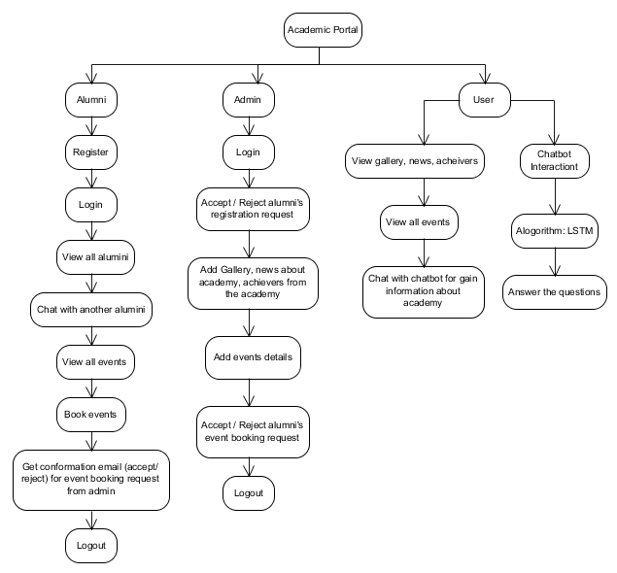

**4. METHODOLOGY**

**4.1 Backend Development**

* Admin Module: Development of functionalities to manage alumni registrations, event approvals, and updates to academy news, galleries, and achiever details.
* Alumni Module: Creation of a secure login and dashboard for alumni to interact with the system, including viewing other alumni, booking events, and engaging in one-on-one chat via a chatbox.
* User Module: Enabling guest users to explore public academy content and interact with the chatbot for general inquiries about the institution.
* Email Notification System: Implementing an automated system to send email notifications to alumni regarding event registration and booking status.

**4.2 Chatbot Development (LSTM-Based)**

The chatbot development process involves multiple stages, from data preparation to model deployment. The steps below outline the methodology for creating the Alumni Network Chatbot using Machine Learning and Natural Language Processing (NLP) techniques, with a focus on utilizing an LSTM-based model for intent recognition and response generation.

**1. Data Collection and Preprocessing:**

* Data Source: The intents and responses are collected from a predefined dataset stored in a JSON or Excel file (intents.json or enhanced_chatbot_intents_reference.xlsx), containing examples of user queries and their corresponding intents and responses.
* Text Extraction: Extract the user queries (texts) and intents from the dataset. These form the basis of training data for the chatbot.
* Tokenization: The Tokenizer class from TensorFlow's Keras library is used to convert user queries into sequences of integers, with each integer representing a unique word. This process helps prepare the input data for the LSTM model.
* Padding Sequences: Since the length of user queries may vary, the sequences are padded to ensure uniform input size, using the pad_sequences() function to maintain consistency in training.

**2. Label Encoding:**

* Intent Encoding: Using LabelEncoder, the text-based intents are transformed into numeric labels. These labels correspond to different intent categories such as "greeting," "event_booking," or "general_query."
* One-Hot Encoding: The encoded intent labels are further transformed into one-hot vectors, which are used as the output during model training for multi-class classification.

**3. Model Architecture:**

* Input Layer: An input layer is created with a shape based on the maximum length of the padded sequences.
* Embedding Layer: An embedding layer is applied to transform the tokenized words into dense word vectors, helping the LSTM model capture the semantic meaning of the words.
* LSTM Layer: A Long Short-Term Memory (LSTM) layer is employed to learn long-term dependencies in the input sequences. The LSTM is well-suited for NLP tasks as it can capture contextual information over long sentences.
* Dense Layer: The final output layer is a dense layer with softmax activation, which outputs the probability distribution over the different intent classes. This helps in identifying the most likely intent based on the user input.

**4. Model Training:**

* The model is compiled with the categorical cross-entropy loss function and the Adam optimizer, ensuring efficient training of multi-class classification.
* The padded user queries and one-hot encoded intents are used to train the model over several epochs (e.g., 50 epochs), allowing the LSTM model to learn the mapping between user inputs and their corresponding intents.

**5. Saving the Model and Tokenizers:**

* After training, the model is saved to a file (chatbot_model.h5) for later use in making predictions.
* The tokenizer and label encoder are also saved (tokenizer.pickle and label_encoder.pickle) to preprocess new user inputs during the chatbot’s prediction phase.

**6. Intent Prediction and Response Generation:**

* Input Preprocessing: For user inputs during real-time chatbot interaction, the text is tokenized, and the sequence is padded to match the input shape expected by the LSTM model.
* Prediction: The trained model predicts the intent by generating a probability distribution over all intents, and the intent with the highest probability is selected.
* Response Generation: Based on the predicted intent, a corresponding response is retrieved from the dataset. If multiple responses are available for the same intent, a random response is chosen to introduce variability and make the chatbot feel more dynamic.

**7. Chatbot Features:**

* Handling User Names and Context: The chatbot can personalize conversations by storing the user's name after it's provided. The chatbot also includes logic for handling conversation termination ("bye" intent) and confirming the user’s intent to end the chat.
* Response Handling: The chatbot can engage with users by recognizing special commands or inputs (like asking for the user’s name or confirming if they want to end the conversation) and generating personalized responses based on the context.

**8. Testing and Deployment:**

* Testing: The chatbot is rigorously tested for intent recognition accuracy and response generation to ensure it handles various user inputs effectively.
* Deployment: Once the chatbot is fully trained and tested, it can be integrated into the alumni network platform to assist users with inquiries related to event booking, academy details, or general queries.

By following this methodology, the chatbot becomes an efficient and user-friendly tool that enhances user experience by automating query handling and improving alumni engagement. The use of LSTM networks allows the chatbot to understand context better and respond accurately to varied user inputs.

**4.3 Front-End Development**

* User Interface Implementation: Building the front-end components for alumni, admin, and guest interactions. The front-end communicates with the back-end APIs for data retrieval and submission.
* Chatbox for Alumni: Developing a real-time, secure chatbox feature for alumni to interact with each other. Messages are stored in the database and displayed in a user-friendly interface.
* Chatbot Integration: Embedding the LSTM-powered chatbot into the front end, accessible by both registered users and guests. The chatbot is integrated to answer queries about the academy, available courses, and events.

# **5. REQUIREMENT ANALYSIS**

## **5.1 Function and non-functional requirements**

Requirement’s analysis is very critical process that enables the success of a system or software project to be assessed. Requirements are generally split into two types: Functional and non-functional requirements.

**Functional Requirements**: These are the requirements that the end user specifically demands as basic facilities that the system should offer. All these functionalities need to be necessarily incorporated into the system as a part of the contract. These are represented or stated in the form of input to be given to the system, the operation performed and the output expected. They are basically the requirements stated by the user which one can see directly in the final product, unlike the non-functional requirements.

Examples of functional requirements:

1. Authentication of user whenever he/she logs into the system
2. System shutdown in Solar prediction.
3. A verification email is sent to user whenever he/she register for the first time on some software system.

**Non-functional requirements**: These are basically the quality constraints that the system must satisfy according to the project contract. The priority or extent to which these factors are implemented varies from one project to other. They are also called non-behavioral requirements.

They basically deal with issues like:

* Portability
* Security
* Maintainability
* Reliability
* Scalability
* Performance
* Reusability
* Flexibility

Examples of non-functional requirements:

1. Emails should be sent with a latency of no greater than 12 hours from such an activity.
2. The processing of each request should be done within 10 seconds
3. The site should load in 3 seconds whenever of simultaneous users are > 10000

## **5.2 Hardware Requirements**

Processor - I3/Intel Processor

Hard Disk - 160GB

Key Board - Standard Windows Keyboard

Mouse - Two or Three Button Mouse

Monitor - SVGA

RAM - 8GB

## **5.3 Software Requirements**

* Operating System : Windows 7/8/10
* Programming Language : Python
* Libraries : Pandas, Numpy, scikit-learn.
* IDE/Workbench : Visual Studio Code.

# **SYSTEM DESIGN**

## **6.1 UML diagrams**

UML stands for Unified Modelling Language. UML is a standardized general-purpose modelling language in the field of object-oriented software engineering. The standard is managed, and was created by, the Object Management Group. The goal is for UML to become a common language for creating models of object-oriented computer software. In its current form UML is comprised of two major components: a Meta-model and a notation. In the future, some form of method or process may also be added to; or associated with, UML.

The Unified Modelling Language is a standard language for specifying, Visualization, Constructing and documenting the artefacts of software system, as well as for business modelling and other non-software systems. The UML represents a collection of best engineering practices that have proven successful in the modelling of large and complex systems.

The UML is a very important part of developing objects-oriented software and the software development process. The UML uses mostly graphical notations to express the design of software projects.

**GOALS:**

The Primary goals in the design of the UML are as follows:

1. Provide users a ready-to-use, expressive visual modelling Language so that they can develop and exchange meaningful models.
2. Provide extendibility and specialization mechanisms to extend the core concepts.
3. Be independent of particular programming languages and development process.
4. Provide a formal basis for understanding the modelling language.
5. Encourage the growth of OO tools market.
6. Support higher level development concepts such as collaborations, frameworks, patterns and components.
7. Integrate best practices.

### **USE CASE DIAGRAM**

A use case diagram in the Unified Modeling Language (UML) is a type of behavioral diagram defined by and created from a Use-case analysis. Its purpose is to present a graphical overview of the functionality provided by a system in terms of actors, their goals (represented as use cases), and any dependencies between those use cases. The main purpose of a use case diagram is to show what system functions are performed for which actor. Roles of the actors in the system can be depicted.

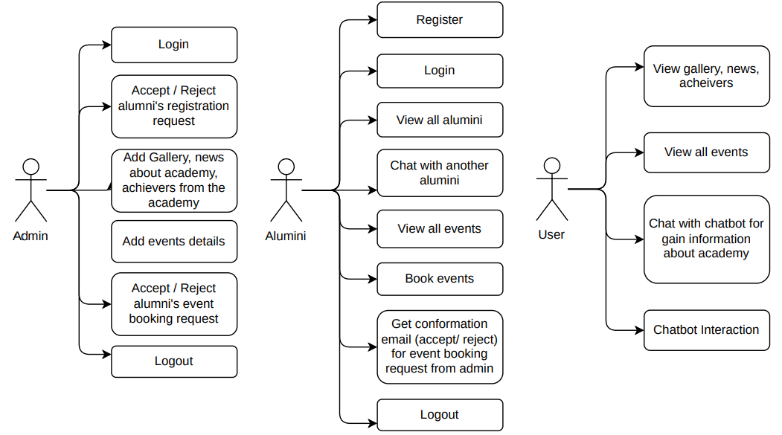

### **6.1.2 CLASS DIAGRAM**

In software engineering, a class diagram in the Unified Modeling Language (UML) is a type of static structure diagram that describes the structure of a system by showing the system's classes, their attributes, operations (or methods), and the relationships among the classes. It explains which class contains information

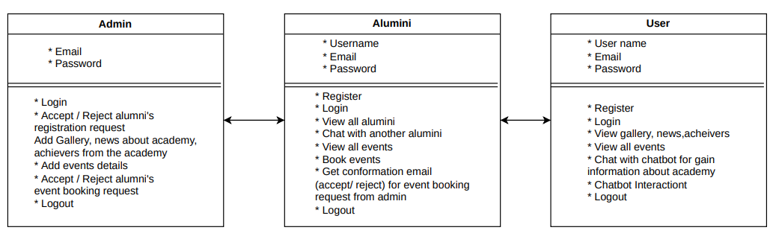

### **SEQUENCE DIAGRAM**

A sequence diagram in Unified Modeling Language (UML) is a kind of interaction diagram that shows how processes operate with one another and in what order.It is a construct of a Message Sequence Chart. Sequence diagrams are sometimes called event diagrams, event scenarios, and timing diagrams

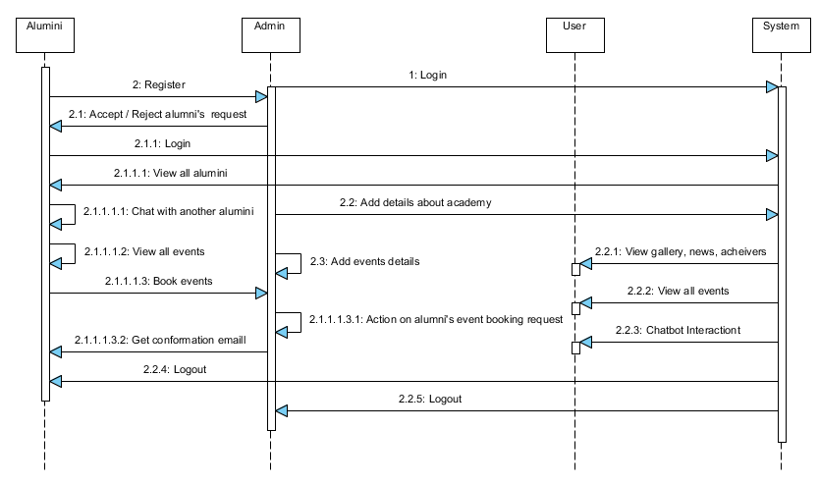

### **6.1.4 COLLABORATION DIAGRAM:**

In collaboration diagram the method call sequence is indicated by some numbering technique as shown below. The number indicates how the methods are called one after another. We have taken the same order management system to describe the collaboration diagram. The method calls are similar to that of a sequence diagram. But the difference is that the sequence diagram does not describe the object organization whereas the collaboration diagram shows the object organization.

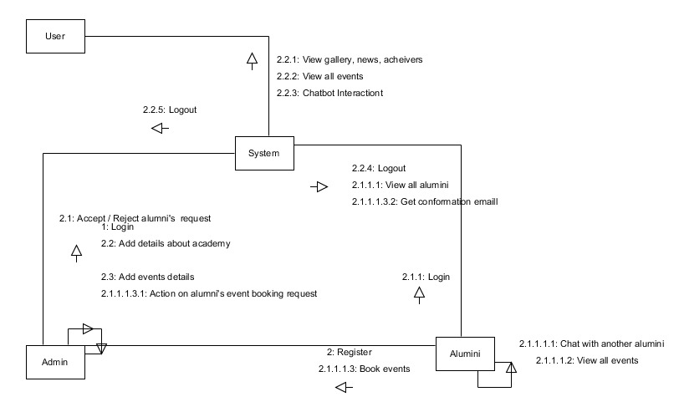

### **6.1.5 DEPLOYMENT DIAGRAM**

Deployment diagram represents the deployment view of a system. It is related to the component diagram. Because the components are deployed using the deployment diagrams. A deployment diagram consists of nodes. Nodes are nothing but physical hardware’s used to deploy the application.

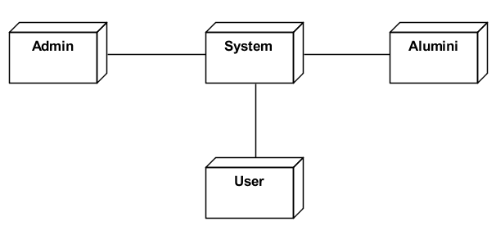

### **6.1.6 ACTIVITY DIAGRAM:**

Activity diagrams are graphical representations of workflows of stepwise activities and actions with support for choice, iteration and concurrency. In the Unified Modelling Language, activity diagrams can be used to describe the business and operational step-by-step workflows of components in a system. An activity diagram shows the overall flow of control.

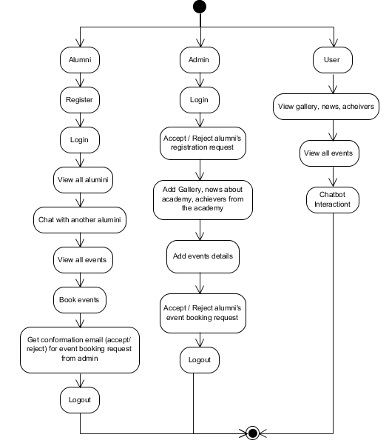

### **6.1.7 COMPONENT DIAGRAM**:

A component diagram, also known as a UML component diagram, describes the organization and wiring of the physical **c**omponents in a system. Component diagrams are often drawn to help model implementation details and double-check that every aspect of the system's required function is covered by planned development.

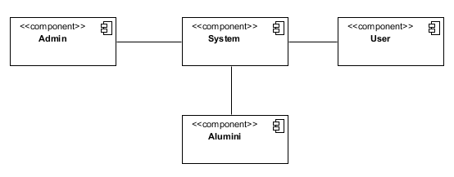

## **6.2 ER DIAGRAM:**

An Entity–relationship model (ER model) describes the structure of a database with the help of a diagram, which is known as Entity Relationship Diagram (ER Diagram). An ER model is a design or blueprint of a database that can later be implemented as a database. The main components of E-R model are: entity set and relationship set.

An ER diagram shows the relationship among entity sets. An entity set is a group of similar entities and these entities can have attributes. In terms of DBMS, an entity is a table or attribute of a table in database, so by showing relationship among tables and their attributes, ER diagram shows the complete logical structure of a database. Let’s have a look at a simple ER diagram to understand this concept.

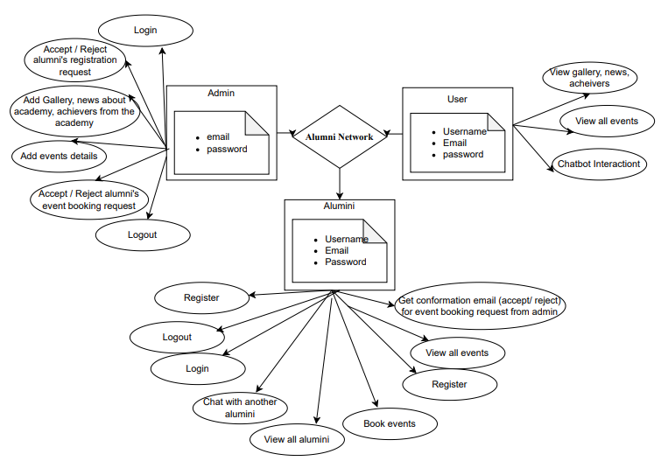

## **6.3 Data Flow diagrams**

A Data Flow Diagram (DFD) is a traditional way to visualize the information flows within a system. A neat and clear DFD can depict a good amount of the system requirements graphically. It can be manual, automated, or a combination of both. It shows how information enters and leaves the system, what changes the information and where information is stored. The purpose of a DFD is to show the scope and boundaries of a system as a whole. It may be used as a communications tool between a systems analyst and any person who plays a part in the system that acts as the starting point for redesigning a system.

**Contrast Level:**

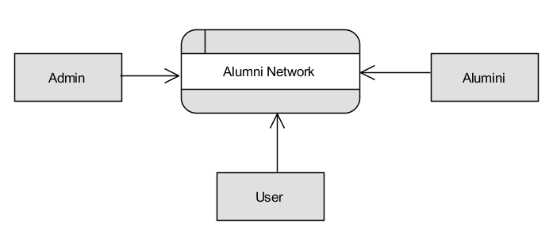

**Level 1 Diagram**:

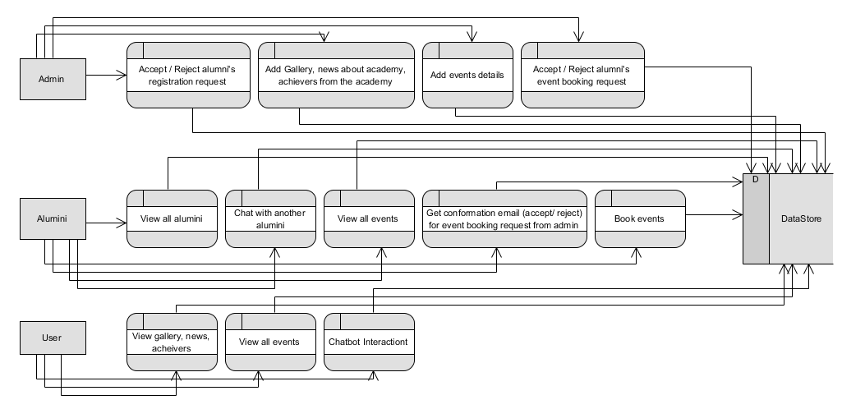

**Level 2 Diagram**:

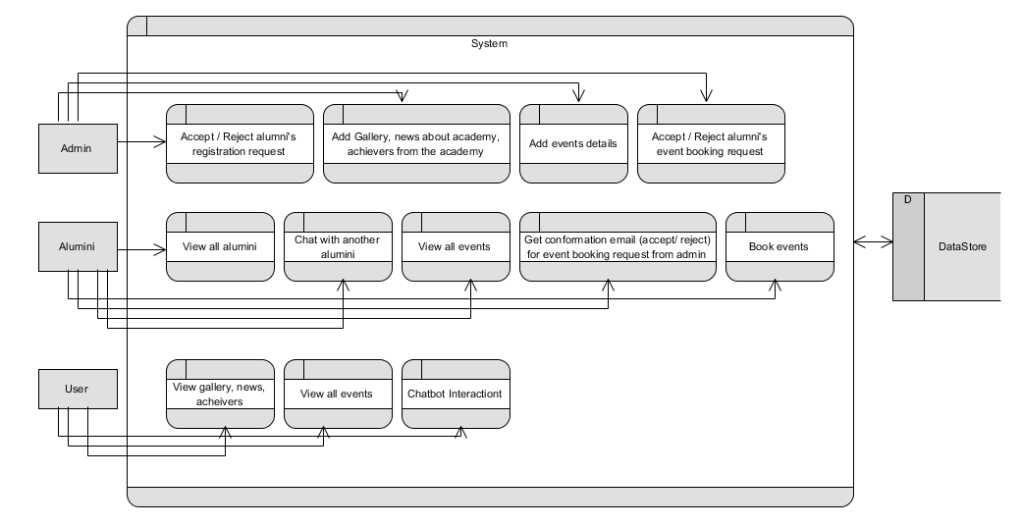

# **7.** **IMPLEMENTATION AND RESULTS**

## **7.1 Modules**

1. **Admin Module:**
   * Manage alumni registrations: Approve or reject alumni registration requests.
   * Manage event bookings: Review and accept or reject alumni event booking requests.
   * Update academy content: Add and manage events, news, gallery images, and information about academy achievers.
   * Email notifications: Automatically send email notifications to alumni regarding the status of event booking requests.
   * View alumni and event data: Admin can view registered alumni details and event booking statuses.
2. **Alumni Module:**
   * Registration: Alumni can submit a registration request, which requires admin approval.
   * Login: After admin approval, alumni can log in to their personalized dashboard.
   * Explore other alumni: Alumni can view profiles of other alumni registered in the system.
   * Chatbox: Alumni can interact with other alumni using a one-on-one chatbox system.
   * Event booking: Alumni can view academy events and send booking requests to the admin.
   * Email notifications: Receive email notifications about the status of event bookings.
   * Logout: Alumni can securely log out of their session.
3. **User Module (Guest/Visitor):**
   * Explore academy content: Users can browse gallery images, academy news, and information about achievers.
   * View event details: Guests can view upcoming academy events without logging in.
   * Chat with the LSTM chatbot: Guests can use the chatbot to get general information about the academy, such as courses, fees, and more.
   * Register as an alumni: Guests who are interested in alumni-related activities can register to become alumni.
4. **LSTM-Based Chatbot Module:**
   * Automated user assistance: The chatbot answers user queries regarding academy details such as fee structure, courses, and more.
   * Accessible by all users: The chatbot is available on the homepage and can be accessed by both registered and non-registered users.
5. **Chatbox Module:**
   * Alumni communication: Allows alumni to chat and interact with each other one-on-one.

Secure interaction: Messages exchanged between alumni are stored securely in the database.

# **CONCLUSION**

The Alumni Network: An Academic Portal using Machine Learning provides a comprehensive solution to the challenges faced by educational institutions in maintaining continuous alumni engagement. By integrating machine learning, specifically an LSTM-based chatbot, the platform automates routine tasks such as query handling, event management, and communication, significantly reducing the manual effort required by administrators. The system enhances user experience through personalized interactions, streamlined alumni data management, and efficient event booking processes.

Moreover, the use of advanced machine learning techniques ensures that the chatbot provides accurate and context-aware responses, improving engagement and satisfaction for alumni and prospective users alike. The platform's secure design, coupled with automated features like email notifications and personalized recommendations, fosters a sense of community and long-term connection between alumni and their alma mater.

Overall, this project not only addresses the current gaps in alumni engagement but also sets a foundation for future scalability and enhancements, such as mobile accessibility and advanced analytics for user behavior. The integration of machine learning elevates the platform beyond traditional systems, offering a modern, efficient, and user-friendly solution for academic institutions to maintain lasting relationships with their alumni.

# **FUTURE ENHANCEMENT**

While the Alumni Network: An Academic Portal using Machine Learning provides a strong foundation for alumni engagement, several potential enhancements can be explored to improve functionality and expand the system's capabilities in the future:

**1. Mobile Application Integration:** Developing a mobile version of the platform can make it more accessible and convenient for users. A mobile app for both Android and iOS would enable alumni to engage with the portal on-the-go, participate in events, and interact with the community more frequently. This would also facilitate push notifications for event reminders and announcements, further enhancing engagement.

**2. Advanced Analytics and Insights:** Integrating advanced analytics to track and evaluate alumni engagement can provide administrators with valuable insights. These analytics could include tracking event participation, communication patterns, and user feedback. Machine learning-based analytics can also predict alumni behavior, helping institutions proactively engage users who may be less active on the platform.

**3. Natural Language Processing (NLP) Improvements:** While the LSTM-based chatbot is effective in handling basic queries, future work could focus on enhancing the chatbot’s ability to manage more complex conversations. Leveraging advanced NLP models such as BERT or GPT-3 could enable the chatbot to understand and respond to more intricate queries, improving user satisfaction. Additionally, adding multilingual support would allow the system to cater to a diverse user base, making it accessible to international alumni.

**4. Integration with Social Media Platforms:** Integrating the alumni network portal with popular social media platforms like LinkedIn, Facebook, or Twitter could enhance alumni connectivity. This would allow users to share updates, achievements, and events across multiple platforms, increasing visibility and engagement with a broader audience.

These enhancements, along with the continuous development of machine learning techniques, can significantly improve the platform’s capability, scalability, and user experience, ensuring long-term engagement between alumni and their academic institutions.

**REFERENCES**

1. Alumni Relationship Management Using Technology: Leveraging Digital Platforms for Alumni Engagement, Journal of Educational Technology & Society, 2020.
2. Design and Implementation of an Alumni Management System, International Journal of Computer Science and Network Security, 2019.
3. Artificial Intelligence-Powered Chatbots in Higher Education: A Study on Usability and User Experience, Journal of Interactive Learning Research, 2021.
4. Using Long Short-Term Memory (LSTM) Networks for Question-Answering Systems, Journal of Machine Learning Research, 2020.
5. The Role of Chatbots in Education: A Study on the Use of AI-Powered Bots for Student Interaction, Educational Technology & Society, 2019**.**
6. A Web-Based Alumni Portal for Enhancing Engagement, International Journal of Web-Based Learning and Teaching Technologies, 2018.
7. Machine Learning Applications in Education: A Review, IEEE Access, 2021.
8. Implementation of Secure Chat Systems Using Machine Learning in Alumni Networks, Journal of Applied Machine Learning, 2020.
9. Alumni Engagement: Building a Lifelong Relationship through Digital Platforms, Journal of Higher Education Outreach and Engagement, 2020.
10. Enhancing User Experience in Educational Chatbots Using LSTM Networks, Journal of Artificial Intelligence in Education, 2020.